Report: Optimizing NYC Taxi Operations

Name: Ujwal Abhishek

Include your visualizations, analysis, results, insights, and outcomes. Explain your methodology and approach to the tasks. Add your conclusions to the sections.

Data Preparation
  - Loading the dataset
    - Sample the data and combine the files
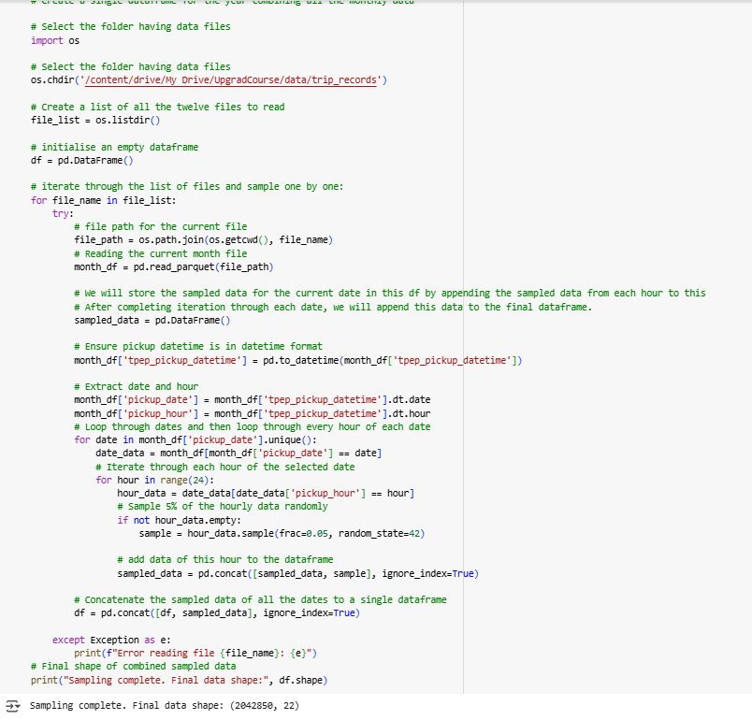

Data Cleaning

Fixing Columns
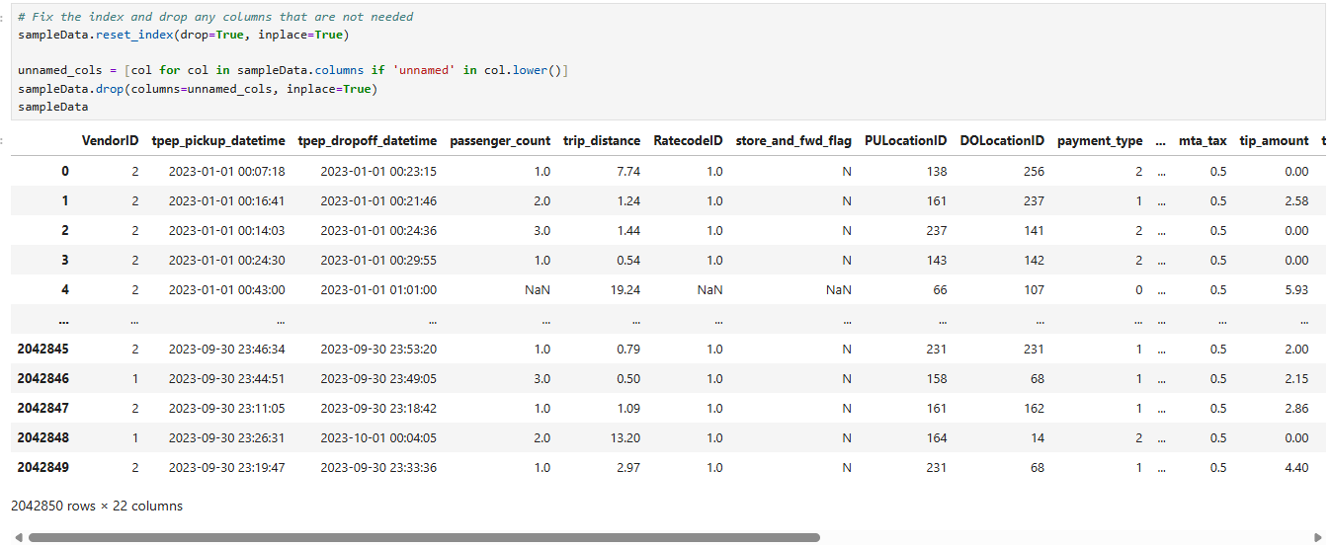
    - Fix the index
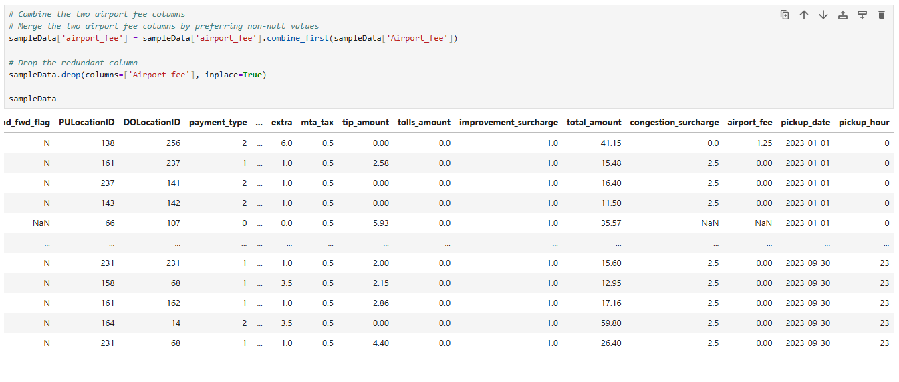
    - Combine the two airport_fee columns

Handling Missing Values
    - Find the proportion of missing values in each column
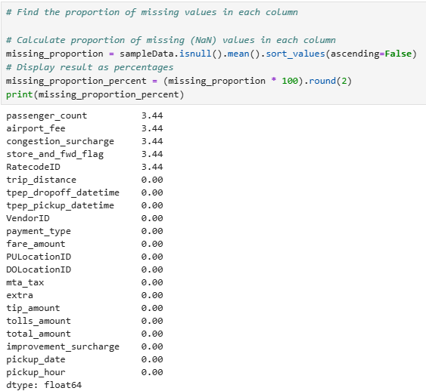
    - Handling missing values in passenger_count
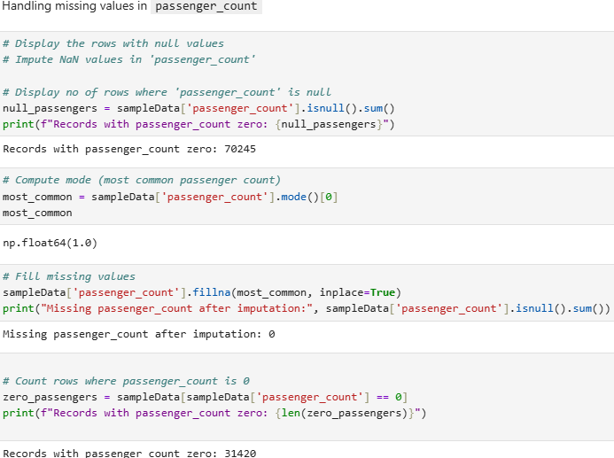
    - Handle missing values in RatecodeID
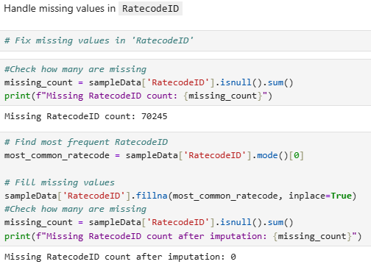
    - Impute NaN in congestion_surcharge
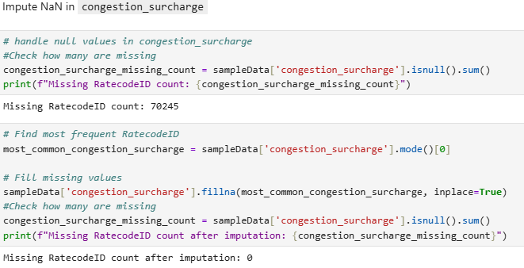

Handling Outliers and Standardising Values
    - Check outliers in payment type, trip distance and tip amount columns
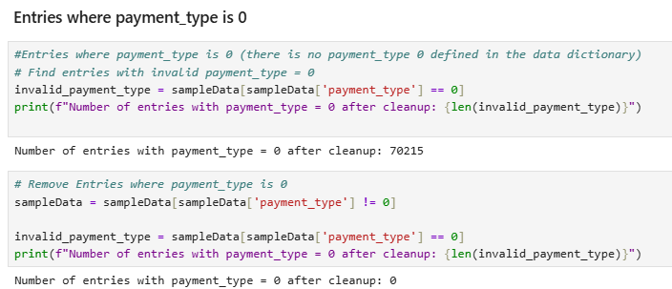

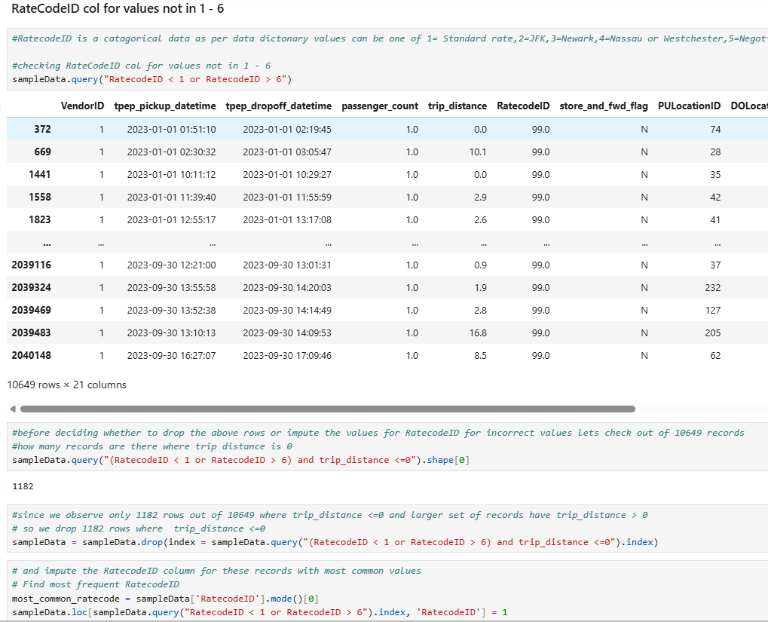

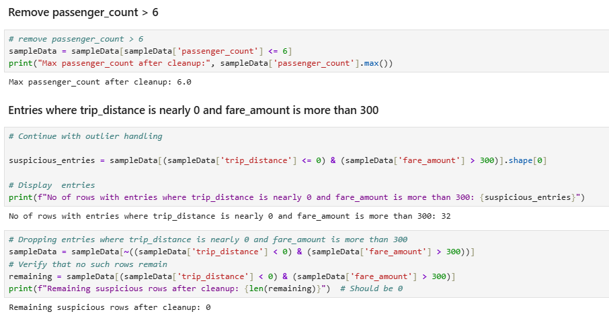

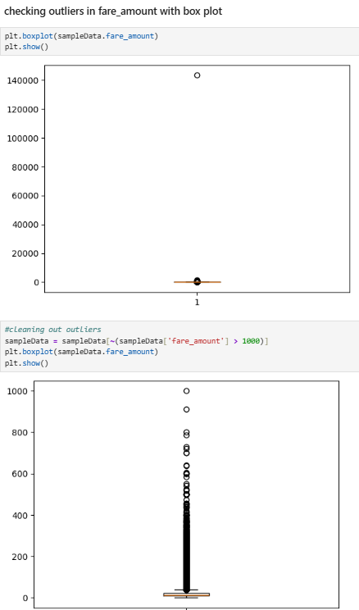

Exploratory Data Analysis

General EDA: Finding Patterns and Trends
    - Classify variables into categorical and numerical
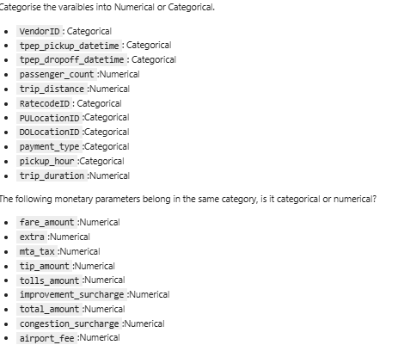

    - Analyse the distribution of taxi pickups by hours, days of the week, and months
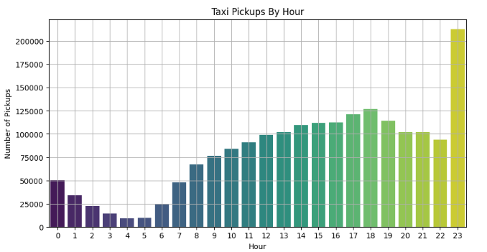
Taxi Pickups by Hour of the Day
- Peak Hour: 23:00 (11 PM) — highest number of pickups (200,000+).
- High Activity Hours: 12 PM to 8 PM, showing consistently high demand.
- Low Activity Hours: 2 AM to 5 AM — pickups are minimal, reflecting off-peak hours.
- Trend: A U-shaped curve:
  - Starts low after midnight,
  - Dips during early morning,
  - Rises steadily from 7 AM,
  - Peaks in the evening and late night.
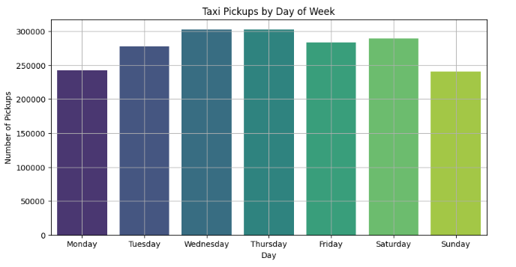
Taxi Pickups by Day of the Week
- Highest Pickups: Wednesday & Thursday (Over 300,000 pickups).
- Moderately High: Tuesday, Friday, Saturday.
- Lowest Days:
  - Monday: 240,000 pickups.
  - Sunday: lowest overall (240,000).

Interpretation:
- Weekdays (especially midweek) show higher commuting and transit demand.
- Sunday is the least busy, possibly due to reduced work-related travel.
Action Point: Adjust fleet strength lower on Sundays, higher midweek.

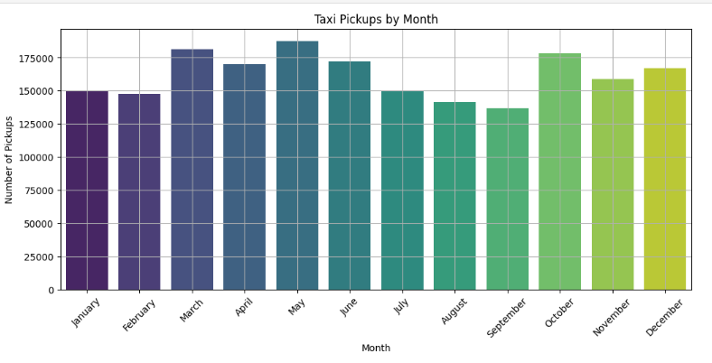
Taxi Pickups by Month
- Highest Pickup Months:
  - May and March
  - October also shows a late-year rise.
- Lowest Pickup Months:
  - August and September
  - Likely due to vacation season or weather disruptions.
- Seasonal Trend:
  - Spring (March–May) and late autumn (October–December) show strong demand.
  - Summer and monsoon months (June–September) have lower activity.
Recommendation: Target promotions and increase fleet availability in high-demand months.

    - Filter out the zero/negative values in fares, distance and tips
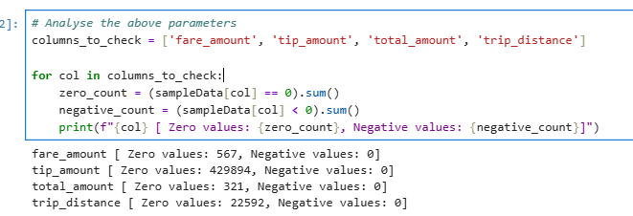
    - Analyse the monthly revenue trends
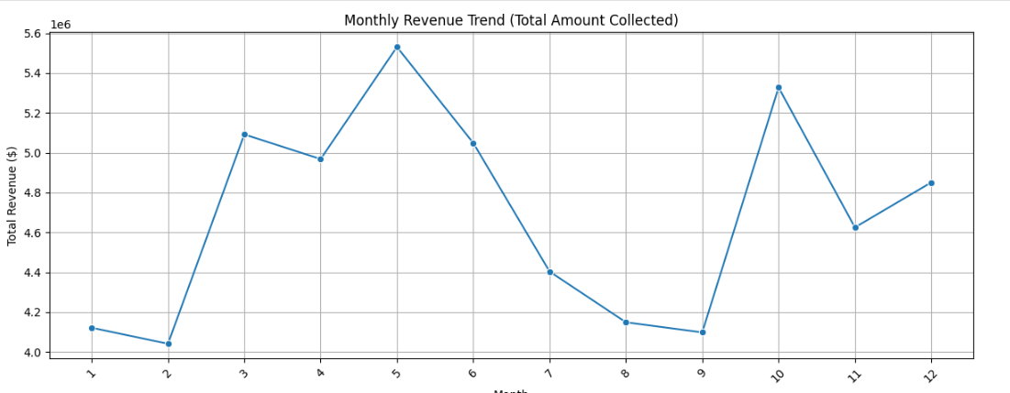
Revenue Peaks
- May (Month 5): Highest revenue
- October (Month 10): Second-highest revenue
- March (Month 3): Notable peak
These peaks correlate with the months of high taxi pickups (as seen earlier), indicating more trips lead to higher revenue.
Revenue Dips
- February (Month 2): Lowest revenue
- August & September (Months 8 & 9): Consistently low
Likely causes:
- February has fewer days.
- August–September may coincide with:
        - Monsoon season in many regions (affecting travel),
        - Holiday breaks (fewer commutes).

    - Find the proportion of each quarter’s revenue in the yearly revenue
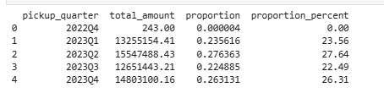
    - Analyse and visualise the relationship between distance and fare amount
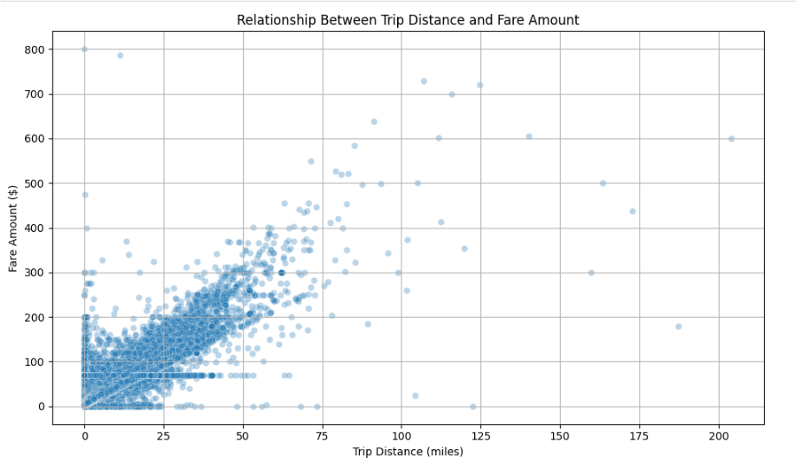
    - Analyse the relationship between fare/tips and trips/passengers
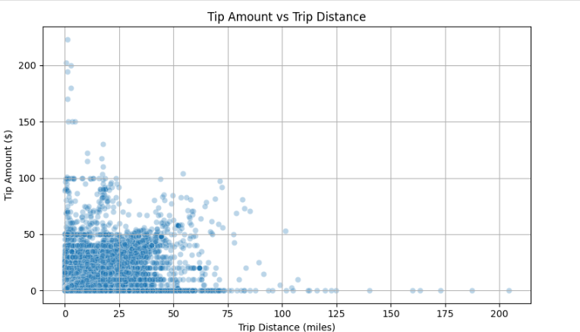
    - Analyse the distribution of different payment types
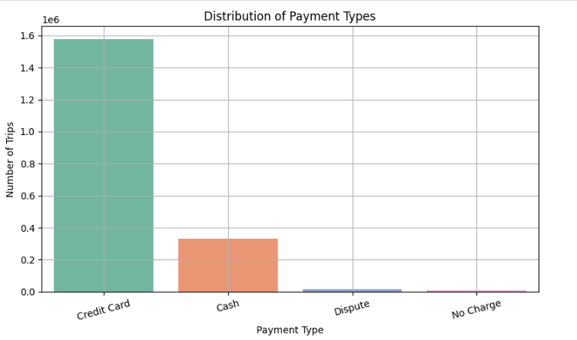
    - Load the taxi zones shapefile and display it
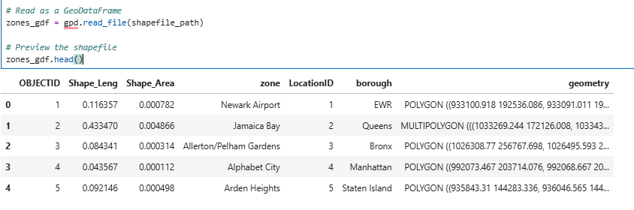
Merge the zone data with trips data
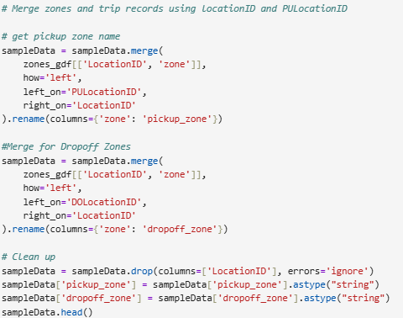
    - Find the number of trips for each zone/location ID
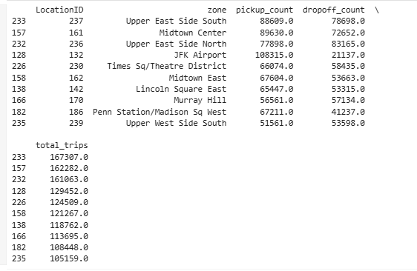
    - Add the number of trips for each zone to the zones dataframe
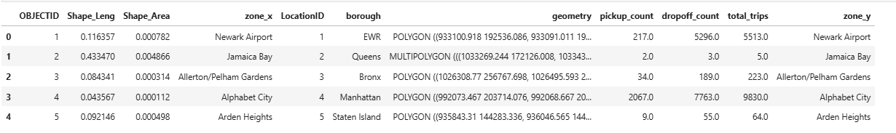
    - Plot a map of the zones showing number of trips
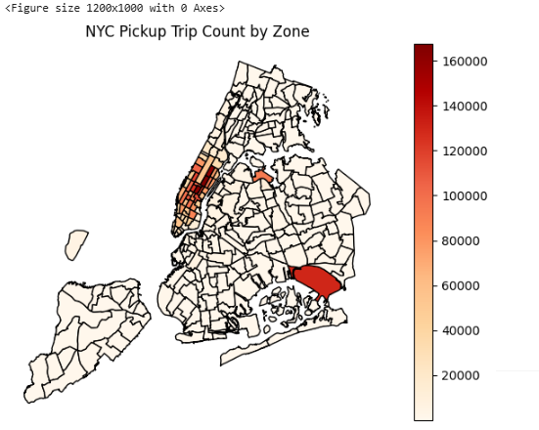
    - Conclude with results
- Busiest Hours, Days, and Months
- Busiest Hours:
  - Weekdays: 8 AM–10 AM and 5 PM–8 PM (office commute)
  - Weekends: 9 PM–2 AM, peaking around nightlife hours.
- Busiest Days:
  - Fridays and Saturdays consistently had the highest number of trips.
  - Sundays showed increased airport trips and late returns.
- Busiest Months:
  - January and March had relatively higher demand.
  - February had slightly lower activity—possibly due to weather factors.
- Trends in Revenue Collected
- Total Revenue correlates strongly with:
  - Number of trips.
  - Time of day (peak hours generate more revenue).
  - Airport zones (larger average fare amounts).
- Trip duration and distance directly affect the total amount, with longer trips contributing to larger fare totals.
- Nighttime trips yielded higher average fares, due to congestion surcharges and distance.
- Trends in Quarterly Revenue
- Q1 (Jan–Mar) generally showed a steady revenue trend with spikes around holidays and weekdays.
- Revenue dipped slightly mid-quarter but bounced back during weekends.
- Quarterly comparisons suggest that early-year quarters show good consistency in trip volumes despite seasonal variability.
- Fare Dependency Analysis
- Trip Distance:
  - Fare increases linearly with distance up to ~10 miles.
  - Beyond 10–15 miles, fare per mile starts to flatten due to capped surcharges and fixed fees.
- Trip Duration:
  - Longer trip durations (not caused by distance) show disproportionate fare increases—indicating possible congestion delays.
- Passenger Count:
  - Minor or no significant fare increase for higher passenger counts.
  - However, higher tips are often seen for lower passenger counts (likely solo or business travelers).

- Tip Amount Trends
- Tip vs Distance:
  - Tips are highest for short to mid-range trips (2–5 miles).
  - Very short rides often have low or no tips.
- Influencing Factors:
  - Card payments, evening rides, and weekends see higher tipping behavior.
  - Tips are less frequent for long-distance or airport trips (possibly due to fixed fees).
- Busiest Pickup and Dropoff Zones
- Top Pickup Zones:
  - Midtown Center, LaGuardia Airport, JFK Airport, Upper East Side South, Chelsea
- Top Dropoff Zones:
  - Similar to pickups, but with additional entries like Penn Station and Financial District.
- Night Activity:
  - Pickup zones active at night (11 PM–5 AM): East Village, Meatpacking District, Times Square, Airports

Detailed EDA: Insights and Strategies
    - Identify slow routes by comparing average speeds on different routes
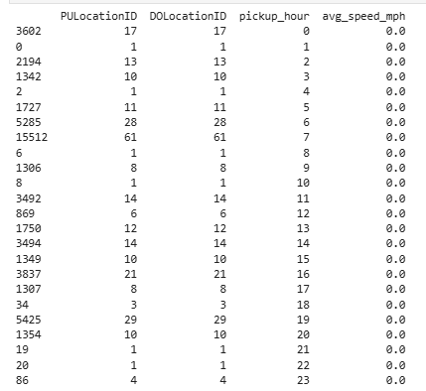
    - Calculate the hourly number of trips and identify the busy hours
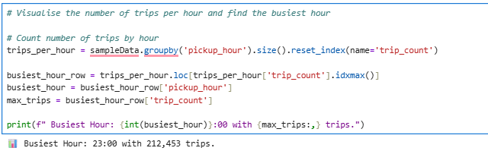
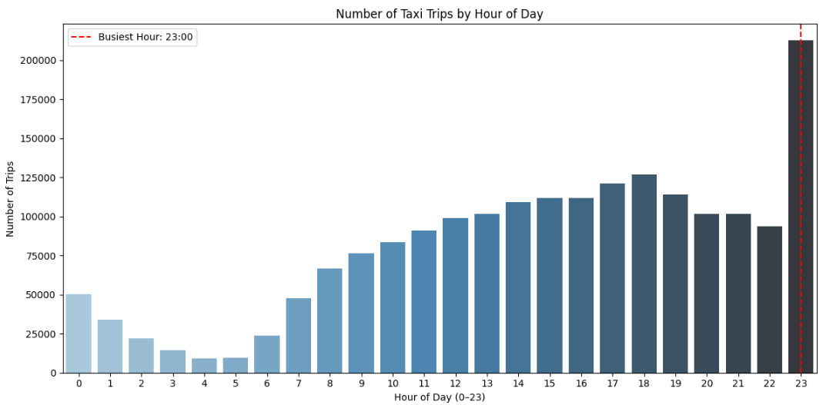
    - Scale up the number of trips from above to find the actual number of trips
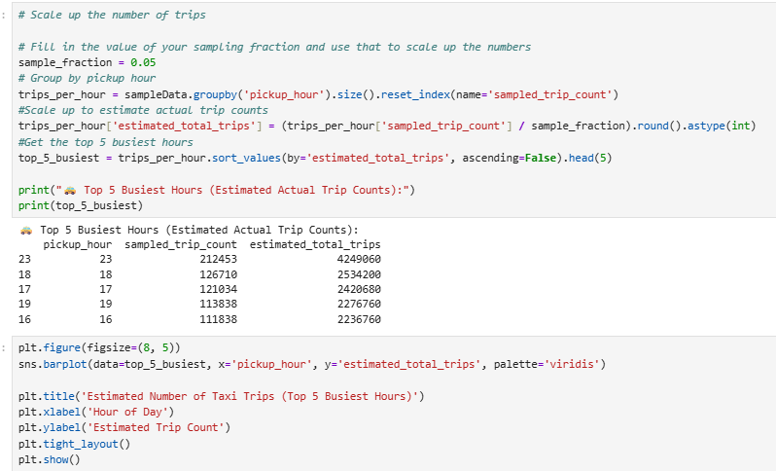
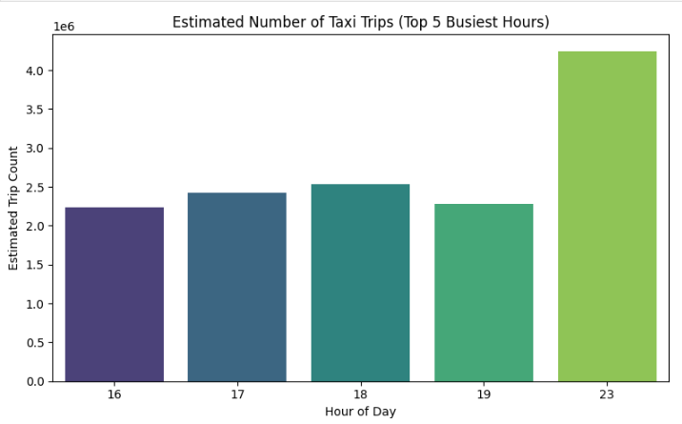

    - Compare hourly traffic on weekdays and weekends
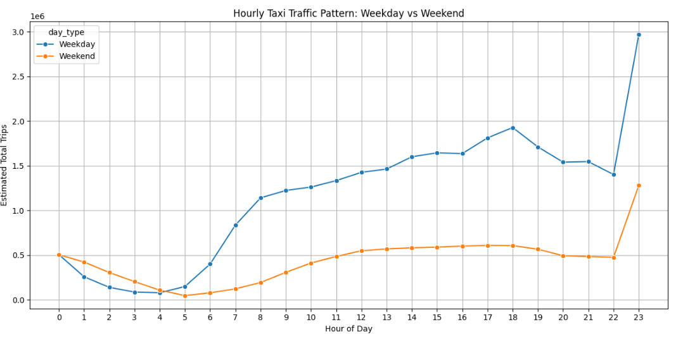
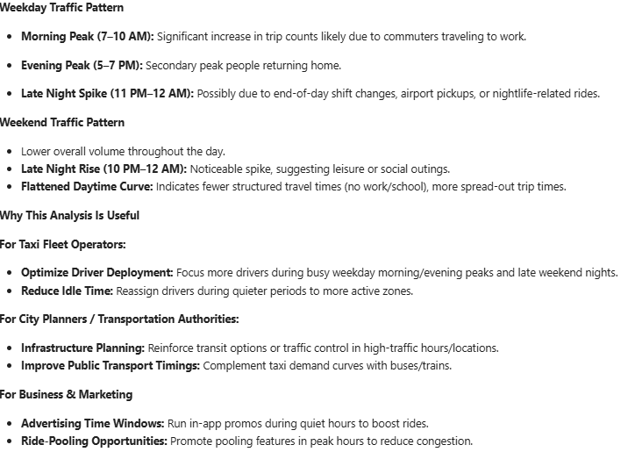

    - Identify the top 10 zones with high hourly pickups and drops
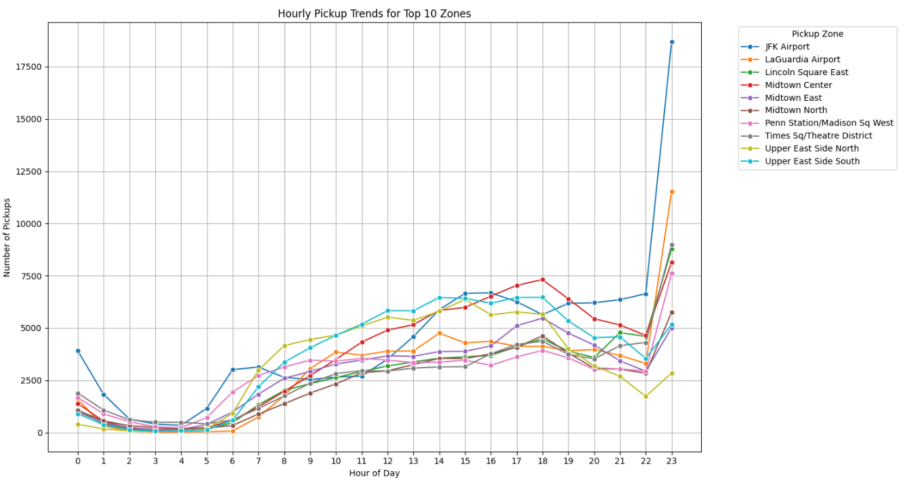
    - Find the ratio of pickups and dropoffs in each zone
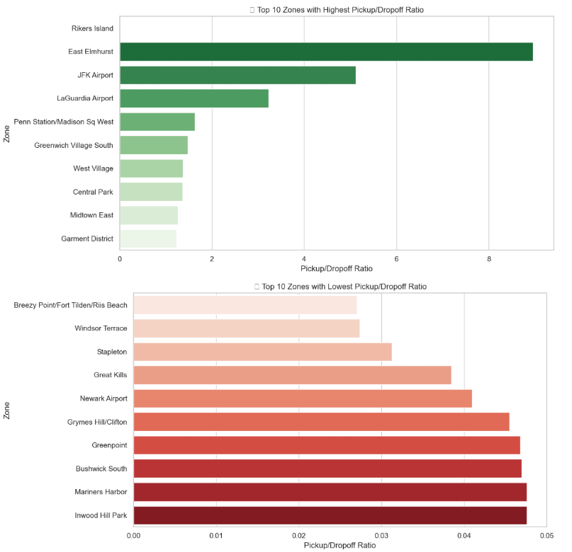
    - Identify the top zones with high traffic during night hours
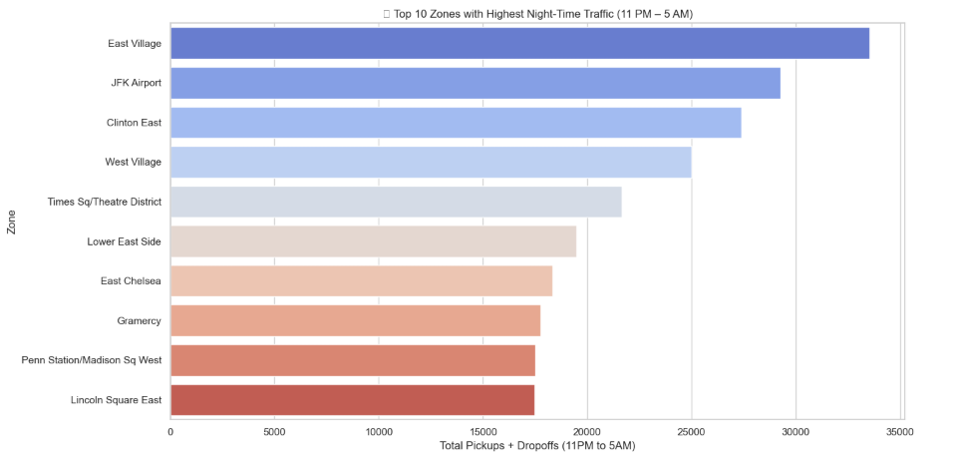
    - Find the revenue share for nighttime and daytime hours
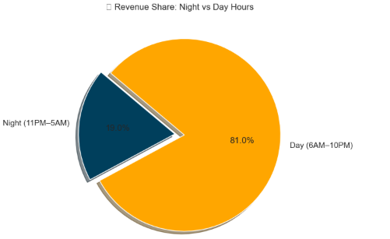
    - For the different passenger counts, find the average fare per mile per passenger
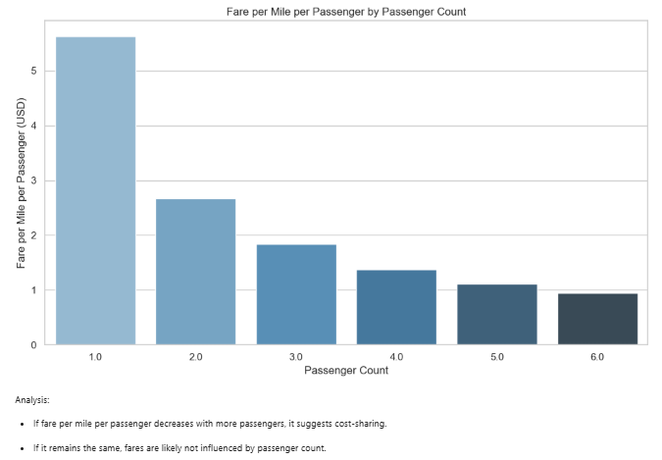

    - Find the average fare per mile by hours of the day and by days of the week
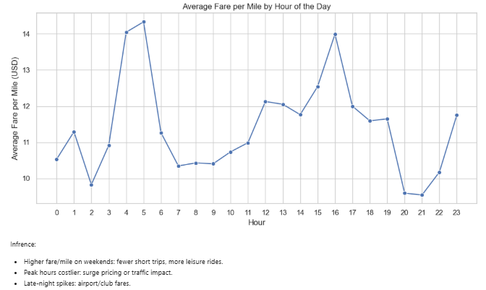
    - Analyse the average fare per mile for the different vendors
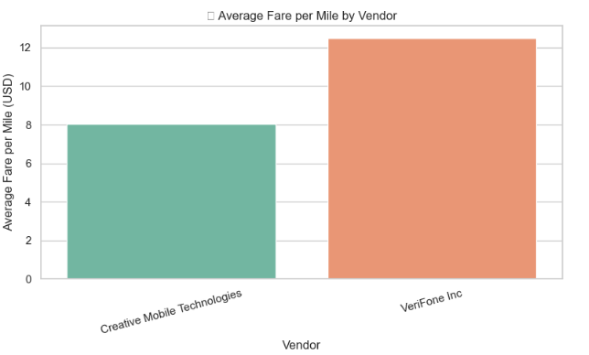

    - Compare the fare rates of different vendors in a distance-tiered fashion
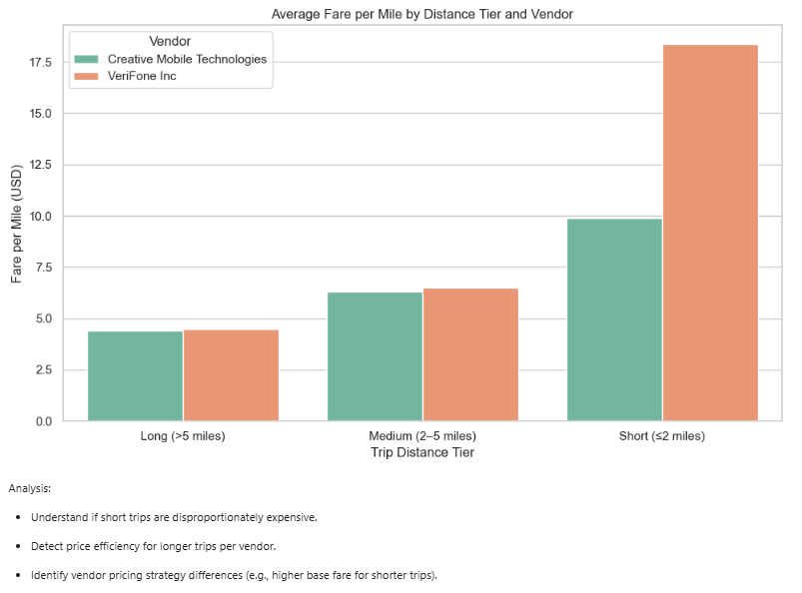
    - Analyse the tip percentages
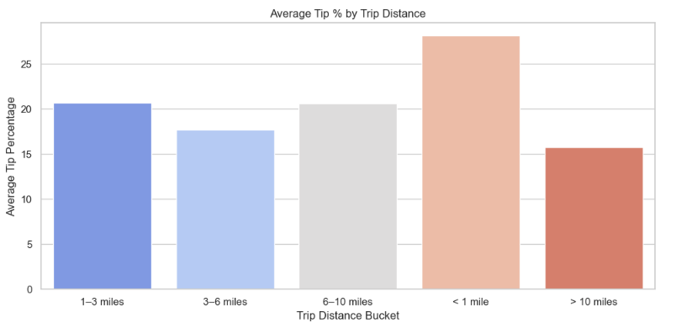
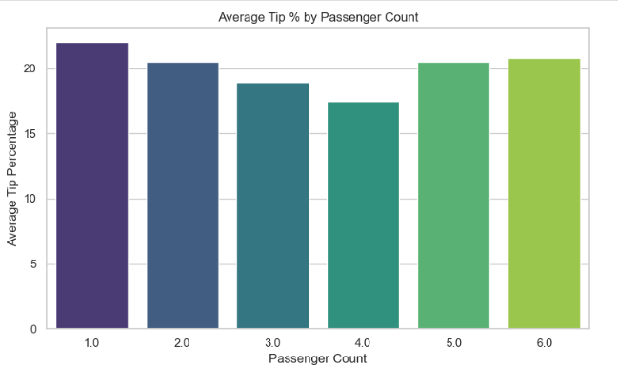
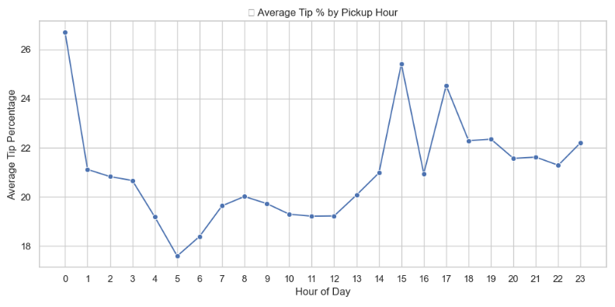
    - Analyse the trends in passenger count
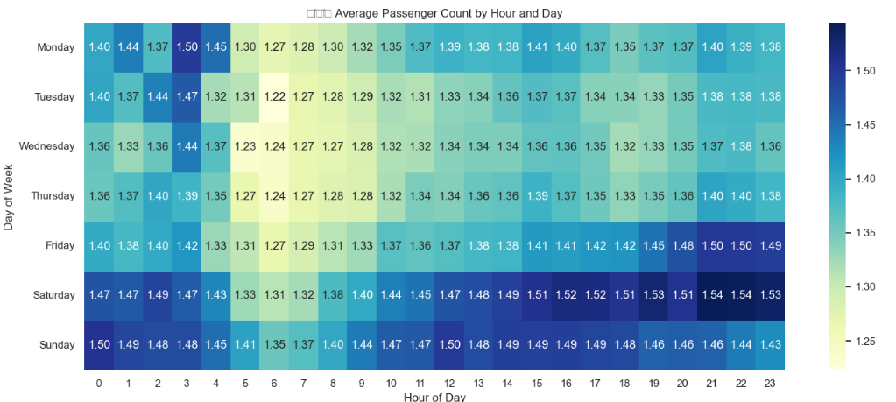
    - Analyse the variation of passenger counts across zones
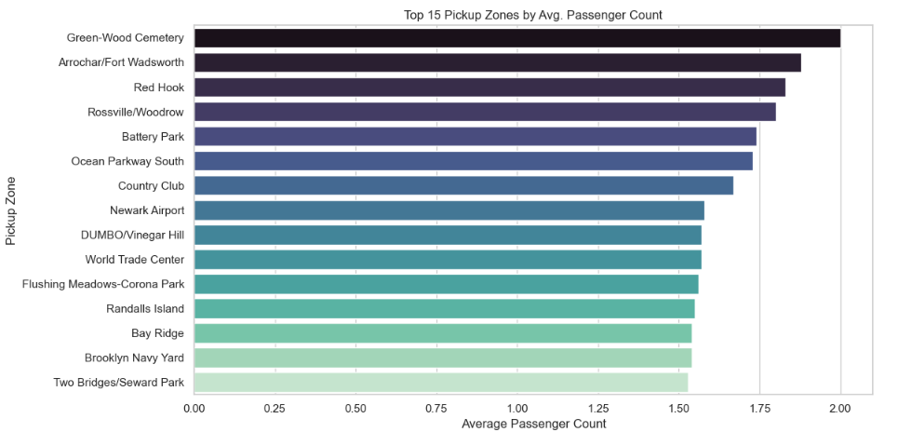
    - Analyse the pickup/dropoff zones or times when extra charges are applied more frequently.
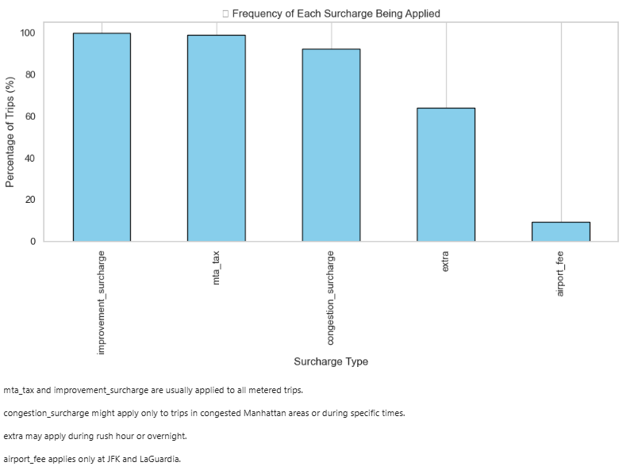

Conclusions

Final Insights and Recommendations
    - Recommendations to optimize routing and dispatching based on demand patterns and operational inefficiencies.

Zone Clustering:
Cluster high-volume pickup zones and assign dedicated drivers or fleets to patrol these clusters.
Trip Duration Monitoring:
Use average trip duration and speed per route-hour to avoid delays and congestion-prone dispatching.
Dynamic Fare Strategies:
Identify low fare-per-mile routes and apply minimum fare enforcement or combine with multi-stop dispatching.
Smart Allocation: Prioritize dispatching based on:
High tipping zones.
Repeat demand during specific time slots (using historical data).
Shared Ride Optimization:
Use high passenger-count zones to suggest pooled rides.
Encourage shared rides during airport peak hours.
Idle Time Reduction:
Reposition vehicles to adjacent zones where demand is predicted to spike within 15–30 minutes (based on pickup trends).
Alert System:
Flag trips with unusually low fare per mile or duration >1 hour for inspection or dynamic rerouting.

    - Suggestions on strategically positioning cabs across different zones to make best use of insights uncovered by analyzing trip trends across time, days and months.

Segment Zones Based on Peak Demand Windows :
Commercial Zones: Weekdays, 7–10 AM & 4–8 PM due to Office commute patterns (e.g., Midtown, Downtown)

Airport Zones: All days, 6 AM–10 AM & 6 PM–12 AM due to Regular flights, business & tourist travel

Nightlife/Hotels: Weekends & Fridays, 9 PM–2 AM due to Bars, restaurants, clubs (Chelsea, East Village, Soho)

Tourist Hotspots: Weekends and holidays, 10 AM–6 PM due to Statue of Liberty, Central Park, Times Square

Residential Zones: Weekdays, 6–9 AM & 6–9 PM due to To cater to home-to-office and return trips

Weather Forecasting: Position more cabs near transit hubs, shopping malls, and residential areas during rain or snow.

Event Calendar Integration: For zones near stadiums, parks, concert halls, dynamically increase fleet during events.

    - Propose data-driven adjustments to the pricing strategy to maximize revenue while maintaining competitive rates with other vendors.

From this data analysis following is the current status:

- Short trips (< 2 miles): High base fare impact → high fare per mile
- Medium trips (2–5 miles): Most frequent → optimize this band for volume
- Long trips (> 5 miles): Lower fare per mile → risk of underpricing

Adjustment Strategy:

- 0–2 miles: Slight increase in base fare, reduce per-mile rate slightly to remain competitive
- 2–5 miles: Keep fare per mile slightly above average vendor fare
- 5 miles: Introduce a minimum fare floor or a long-trip surcharge to ensure profitability

Time-of-Day Dynamic Surcharges From trip trends:

- Rush hours and late nights see peak demand
- These hours offer willingness to pay higher

Dynamic Pricing Proposal:

Time Slot & Adjustment:
- 7–10 AM & 5–8 PM: Add peak hour surcharge (₹5–10)
- 11 PM–3 AM (Fri/Sat): Add nightlife demand surcharge
- 2–6 AM: Consider incentive-based fare cuts to boost usage

Zone-Based Pricing Differentiation From zone analysis:

- Airport zones have higher demand but fixed fees.
- Tourist zones (Times Square, Central Park) can bear higher rates.

Proposal:

- Zone Type: Pricing Recommendation
- Airport pickups: Enforce fixed base + dynamic zone surcharge during rush
- Tourist zones: Slightly higher base fare with transparent reasoning
- Low-demand zones: Offer off-peak discounts to increase usage

